# Labsheet 3

## 1.1 Overview

Core Design is a small start-up web design and development company. They have decided to design their website to provide information about their services, and to display their work.

As the website is likely to be the first contact a prospective customer will have with Core Design, it is important that the site should adhere to good design principles so that it meets the expectations of all users.

In this exercise, you will start the process of building the site.

## 1.2 Basic Site Design

Home

About Us

Services

Clients

Contact



The site map describes the architecture of the Web site. It is important to create a site map before building the pages as it helps with navigation design and indicates links between pages.

The initial site map shows five pages, a Home page linking four main content pages:

1. About Us
2. Services
3. Clients
4. Contact Us

## 1.3 Page Layout

The next step is to choose an appropriate layout for the web pages in the site. Some sites use different layouts for different sections but we will start with a simple layout consisting of four sections in the page.

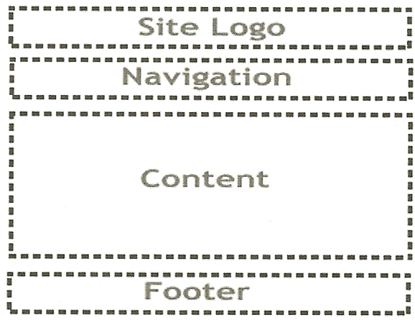

It is important that site design is consistent, i.e. all (similar) pages in the site should follow the same layout/ design. Otherwise, a user may get confused and unable to find the information he or she requires.

The design above consists of four sections. Of these, only the content are will be different in each page. The site logo, navigation, and footer will be the same for all pages in the site.

Although pages will change during the design and development process, the basic layout will be maintained with few changes.

## 2.1 Build the Home Page

The finished home page should look like this (*Note: the dotted lines are to highlight the page sections only and will not appear in the finished page*)

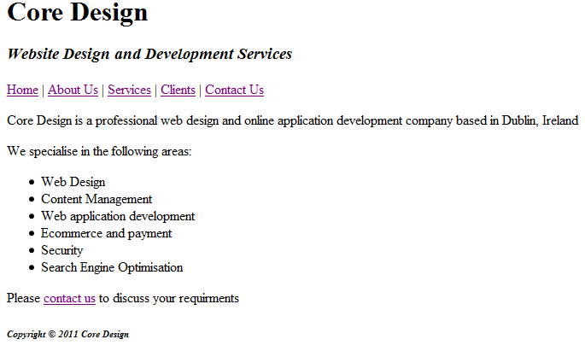

Launch Notepad and create a Web page with the following specifications:

**Web page:** Use a descriptive page title - the company name is a good choice for a business Web site.

**Logo area:** Use <hl> for the Pat the Painter logo. The motto and phone number should be contained within a <h3> element. Emphasize the motto:

Serving the Northwest of Dublin since 1986.

**Navigation:** Place the following text using the <strong> logical style element

within a paragraph:

Home Services Testimonials Free Estimate

Code anchor tags so that Home links to index.html, Services links to services.html, Testimonials links to testimonials.html, and Free Estimate links to

### 2.2 Create a new web page

Open a blank page in a text editor such as Notepad++. Save the file, naming it **index.html**

* Copy the text from the template on Moodle.

Your page should look like this:

<!DOCTYPE html>

<html>

<head>

<title>Page Title</title>

<meta charset="UTF-8">

</head>

<body>

<p>This is my first web page</p>

</body>

</html>

### 2.2.1 Creating the Page Layout

The first stage is to create the layout designed earlier. The four sections will be defined in the page body using html5 tags header, nav, main and footer. These tags were introduced with html5 for use with webpage structure.

Next is the page body with added elements for each section.

<body>

<header>

</header>

<nav>

</nav>

<main>

</main>

<footer>

</footer>

</body>

### 2.2.2 Add Page Content

Section 2.1 shows how the page should look when complete.

Add content to the following sections

#### Header section

Core Design (**Format using <h1>)**

Website Design and Development Services (**format using <h3> and italic <em>)**

#### Nav section

This section is used for the main navigation for the site.

It contains hyperlinks to the other pages, for now set

<a href=”Index.html”>Home</a>

#### Main section

This section will contain the main content of each page.

**Format the first line using <h3>:**

Core Design is a professional web design and online application development company based in Dublin, Ireland

**Format the second line using <h4>:**

We specialise in the following areas:

**Place the following content in an unordered list:**

Web Design

Content Management

Web application development

Ecommerce and payment

Security

Search Engine Optimisation

**Format the last line using <p> and add the contact us link:**

Please contact us to discuss your requirements

#### Footer section

Place the following information in a small text size (use the <h6>) and emphasized font style (use the <em> logical style element):

Copyright © 2018 Core Design

Use **&copy** to show the © symbol

***Save your page and open in a browser***

## 3. To Do

Now that the home page is complete, its time to add more pages. These should be based on the same design as the home page but with different appropriate content. As the basic structure of the pages will be the same, you can copy and paste much of the html code.

Start by adding the “About Us” page. You can make up the content or surf the Internet to get ideas from ‘real’ web design companies.

For the moment, do not worry about complex styling, fonts, colour, or images. Instead, produce an appealing page using only the following tags:

* <h1>, <h2>, <h3>, <h4>, etc.
* <p>
* <strong> and <em>
* Lists

Also add the “Services” page, following the same method as used for the About page.

Finally, update hyperlinks on the three pages, Home.html, About.html, and Services.html. Then test the site in your browser.